**PROJECT 2** 

**Ecommerce website like Flipkart**

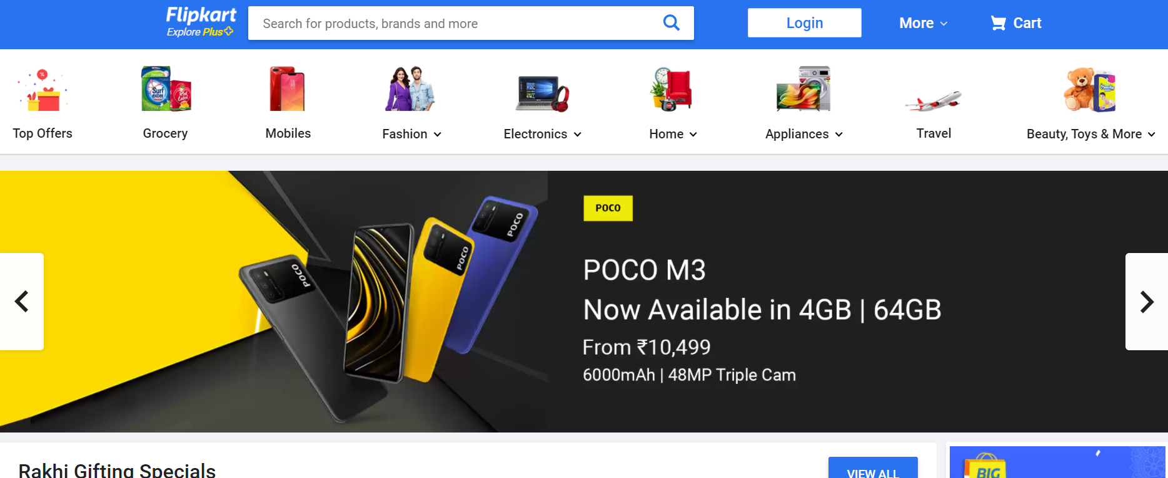

**PAGE (Layout) Description Overview (Page Flow Chart)**

* **Shoppingkart** Logo
* **Search bar** included glyph icon
* **Login** Button with Dropdown (Signup option, My Profile, Orders, Wishlist)
* **Add to Cart** Glyph icon (cart page open when click on it)

Navbar will be sticky while scrolling.



Options like > **Top offers, Mobiles, Fashion, Electronics, Appliances, Beauty products**

with **Images and Dropdowns**

e.g. in Fashion dropdown information like to select below:

Women > **Top, Jeans, skirts, Sarees (this type of info to select and redirect to that page)**

Men > **T-shirt, Shirts Pants, Kurtas (this type of info to select and redirect to that page)**

Ethnic wear for both, Kids section, winter stuff etc.

**< Slide Bar >**

**SLIDER Bar** => Sale offers, Top hot Selling Product

**DIVs** with different sections like:

DIV 1

DIV 2

DIV 3

Below Replica image of divs Note : This will not exactly the same this is just for reference.

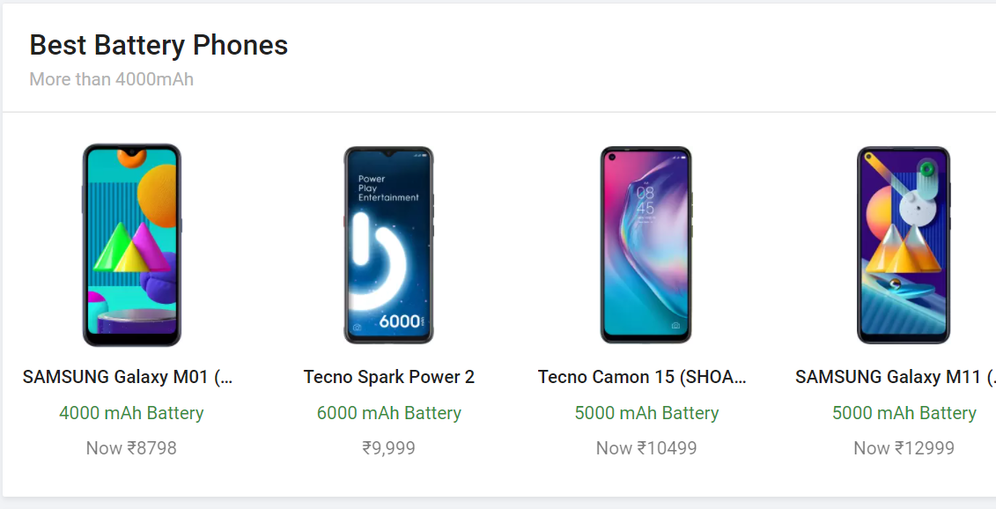

* **Top Fashion Styles,**
* **Best of Electronics,**
* **Men's Footwear,**
* **Fashion for Everyone,**
* **Top Offers on Gaming,**
* **Furniture Bestsellers**:

All included images and information of item which have top picks in different field mentioned.

Also include arrow icon from bootstrap for sliding the div.

|  |  |  |  |
| --- | --- | --- | --- |
| **About Us** | **HELP**  [**Payments**](https://www.flipkart.com/pages/payments) **(payment polices while click on this link new page open)** | **POLICY** | **SOCIAL** |
| **Contact Us (**contact details email ID phn no.in next page) | [**Shipping**](https://www.flipkart.com/pages/shipping) (polices while click on this link new page open) | [**Return**](https://www.flipkart.com/pages/returnpolicy?otracker=undefined_footer_navlinks) | **F**[**acebook**](https://www.facebook.com/flipkart) **(fb link)** |
|  | [**Cancellation & Returns**](https://www.flipkart.com/helpcentre?catalog=55c9c6edb000002e002c1701&view=CATALOG) | [**Terms of Use**](https://www.flipkart.com/pages/terms?otracker=undefined_footer_navlinks) **(polices while click on this link new page open)** | **Twitter (twitter link)** |
| **Stories Press** | [**FAQ**](https://www.flipkart.com/helpcentre?catalog=55c9c8e2b0000023002c1702&view=CATALOG)(polices mentioned while click on this link new page open) | **Policy (polices while click on this link new page open)** | [**YouTube**](https://www.youtube.com/flipkart) **(YT link)** |
| **Wholesale Corporate** | [**Report Infringement**](https://seller.flipkart.com/fiv?otracker=undefined_footer_navlinks)  (polices while click on this link new page open) | [**Security**](https://www.flipkart.com/pages/paymentsecurity?otracker=undefined_footer_navlinks) **(polices while click on this link new page open)** |  |
| **Information** |  | [**Privacy**](https://www.flipkart.com/pages/privacypolicy?otracker=undefined_footer_navlinks) |  |

Copyright Shoppingkart, all type cards pic right side like master card visa rupay  

|  |
| --- |
|  |

**Technologies used to make Shopping kart come in Production**

Front-End:

* Html
* Css
* Bootstrap
* React

For static page layout

Dynamic Page Technologies used:

* JavaScript
* Ci/cd with AWS

Database:

* MongoDB
* Json

Code compilers:

* Visual studio code
* Git bash
* Git hub
* Node.js

Pages in Website

* Shoppingkart main page of deals
* Login Page while click on Login
* Cart page
* Payment Page